**Parental Help**

Submitted in partial fulfillment of the requirements of

**Diploma in Advanced Computing**

By

**Aditya P. Kadam 210943120006**

**Abhishek D. Jawane 210943120035**

**Lalit K. Khomane 210943120049**

**Vrushabh N. Vaidya 210943120116**



**Centre for Development of Advanced Computing**

**INFOWAY, PUNE**

**September 2021**

**CERTIFICATE**

This is to certify that the project entitled **“Parental Help”** is a bonafide work of **“Aditya kadam 210943120006, Abhishek Jawane 210943120035, Lalit Khomane 210943120049, Vrushabh Vaidya 210943120116”** submitted to C-DAC Pune in partial fulfillment of the requirement for the award of the Diploma in Advanced Computing.

Declaration

I declare that this written submission represents our ideas in our own words and where others' ideas or words have been included, we have adequately cited and referenced the original sources. We also declare that we have adhered to all principles of academic honesty and integrity and have not misrepresented or fabricated or falsified any idea/data/fact/source in my submission. We understand that any violation of the above will be cause for disciplinary action by the Institute and can also evoke penal action from the sources which have thus not been properly cited or from whom proper permission has not been taken when needed.

-----------------------------------------

(Aditya Kadam 210943120006)

-----------------------------------------

(Abhishek Jawane 210943120035)

-----------------------------------------

(Lalit Khomane 210943120049)

-----------------------------------------

(Vrushabh Vaidya 210943120116)

**Abstract**

A software product which provides solution for baby health, baby tips, baby products,Doctors, Vaccination centers,babysitters etc.One stop for baby care.The idea is to help people find the best services easily and provide the large base of individuals and small businesses and healthcare professionals with a platform to manage and grow their client network.Parental Help Management System is a platform that aims to effortlessly connect and serve a large local base of individuals with healthcare professionals.

The main scope of this project is to provide Childcare Services at your ease, by suggesting trusted quality products and professionals .One stop for all your baby’s care.Our aim is to connect customers to professionals with ease ,also providing required healthcare products at their doorstep.

**Contents**

|  |  |
| --- | --- |
| **Chapter** | **Contents** |
| **1** | **INTRODUCTION:** |
| **1.1** | **Problem Identification** |
| **1.2** | **Objective of Project** |
| **2** | **Feasibility Study** |
| **3** | **Analysis** |
| **3.1** | **Existing System** |
| **3.2** | **Proposed System** |
| **3.3** | **Software Requirement Specification** |
| **4** | **Design** |
| **4.1** | **UML Diagram** |
| **5** | **Modules** |
| **5.1** | **Module Description** |
| **5.2** | **Introduction of Technology** |
| **6** | **Test Cases** |
| **7** | **Screenshots of Webpages** |
| **8** | **Conclusion** |
| **9** | **Future Enhancement** |
| **10** | **Acknowledgements** |

1. **Introduction**

The main idea of this project is to provide Childcare Services at your ease, by providing trusted quality products and professionals .One stop for all your baby’s care.Our aim is to connect customers to professionals with ease ,also providing required healthcare products at their doorstep.A software product which provides solution for baby health, baby tips, baby products,Doctors, Vaccination centers,babysitters etc.It provides Home Services On Demand by Providing only verified and high quality professional.

This project is a web application in which Admin, users, doctors, babysitters can register on our portal or platform which will help them as well as customers or users to get in touch with each other and have their service get done. In our project there are different services including baby-care products, babysitters if you need assistance, healthcare professionals such as doctors and finally we also have Vaccination centers listed on our portal which will help you find nearest services you require around you within no time. We have added a reminder as well as mail notification service in our system which will help you to connect with the healthcare professionals as well as the notification service will help you to get a reminder based on your service such as vaccination.

**1.1 Problem Identification**

Finding the best healthcare is all we need for our newborn as so as to fulfill the requirement we came up with this idea which will connect users who are in search of healthcare services to the healthcare professionals directly. apart from that our platform is having different services including baby-care products , babysitters if you need assistance, healthcare professionals such as doctors and finally we also have Vaccination centers listed on our portal which will help you find nearest services you require around you.

**1.2 Objective of Project**

With the increase of healthcare services and daily needs and products at doorstep as well as around us ,we need to know what services are nearby us to connect and get in touch with them at ease, That is why we came up with this idea of connecting Childcare professionals to the parents.

The main scope of this project is to provide Childcare Services at your ease and also on your doorstep, by providing trusted quality products and professionals .One stop for all your baby’s care.Our aim is to connect customers to professionals with ease ,also providing required healthcare products at their doorstep.

.

1. **Feasibility Study**

In today’s fast growing and busy world ,every parent looks for an easy convenient and at the same time professional healthcare and childcare service for their loved ones. Finding everything at one spot is the main thing which everyone looks for in today’s busy life. Providing trusted quality service was the main motto of Parental Help management system ,so we came up with this idea as our platform provides major facilities such as Healthcare professionals and vaccination services at one stop .At home, care is typically provided by [nannies](https://en.wikipedia.org/wiki/Nanny), [au pairs](https://en.wikipedia.org/wiki/Au_pair), or friends and family. The child is watched inside the home. This is done with a motive to avoid illnesses from outside interactions. Depending on the number of children in the home, the children utilizing in-home care could enjoy the greatest amount of interaction with their caregiver, in turn forming a close bond. There are no required licensing or background checks for in-home care, making parental vigilance essential in choosing an appropriate caregiver.

Nanny and au pair services provide certified caregivers and the cost of in-home care is the highest of childcare options per child, though a household with many children may find this the most convenient and affordable option. Many nannies study towards childcare qualifications. This training is intended to teach a carer how to create a safe and stimulating environment for children to enjoy and thrive in. Typically, au pairs or nannies provide more than routine child care, often providing assistance with daily household activities which include running errands, shopping, doing laundry, fixing meals, and cleaning the house.

The most now common way to find a healthcare services online on dedicated websites specializing in carer services, or through a nanny agency. Nanny agencies may provide a more thorough check of an applicant's references and run a criminal background check on the successful candidate. Depending on local prices for daycares, a nanny could be cheaper than putting multiple children in a daycare setting full-time. Proponents believe in-home care may provide stability for the child provided the same carer is retained over time.

Nannies often work overtime and babysit. Some also care for sick children whereas nurseries typically do not. This enables the parents to continue working normally without being interrupted. Depending on local laws, some carers can be subject to visits from their local childcare regulatory bodies. Proponents also claim nannies could also be well socialized as nannies could be able to take them out and attend more playdates.

**3.** **Analysis**

**3.1 Existing System**

Existing system were available which offers some of the specifications such as baby food and baby food like first cry. but all the modules such as babysitters, doctors ,vaccinations ,along with baby food and product combine were not available. and trusted childcare services availability is very limitied.

**3.1 Proposed System**

The main scope of this project is to provide Childcare Services at your ease and also on your doorstep, by providing trusted quality products and professionals .One stop for all your baby’s care.Our aim is to connect customers to professionals with ease ,also providing required healthcare products at their doorstep.

**3.3. Software Requirement Specification**

1. Frontend- J

2. Backend- Spring boot

3. Database- MySQL 5.7 with Workbench 8.0

4. Google Chrome version 79.0 5. Apache Tomcat Server 9.0

**3.4. Hardware Requirement Specification**

1. Intel i3 processor 3rd generation or later / AMD Ryzen 200 2nd generation or later

2. 2 GB ddr3 ram.

3. Windows 7 Home edition or later.

4. 200 GB Sata HDD Space

5. Data Connectio

**4. Design**

## **4.1.1 Use Case Diagram: -**

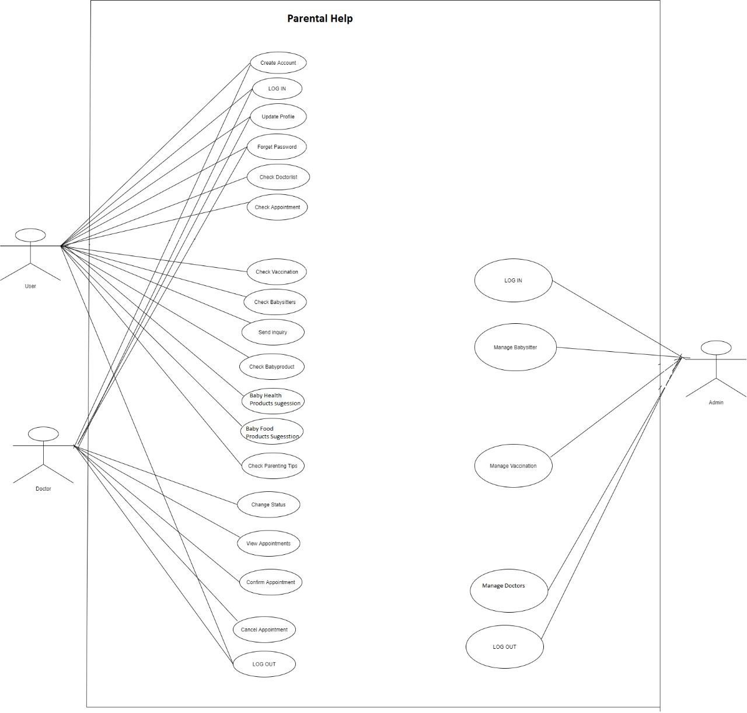

4.1.2 **ER Diagram**

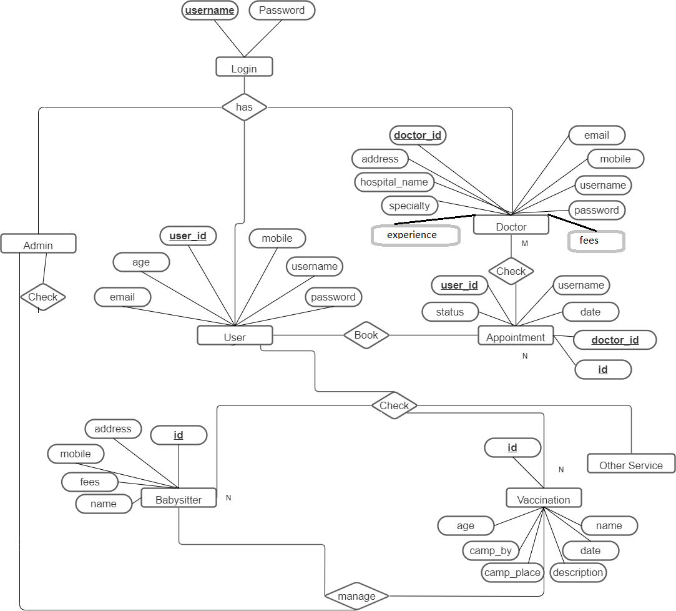

4.2 Class Diagram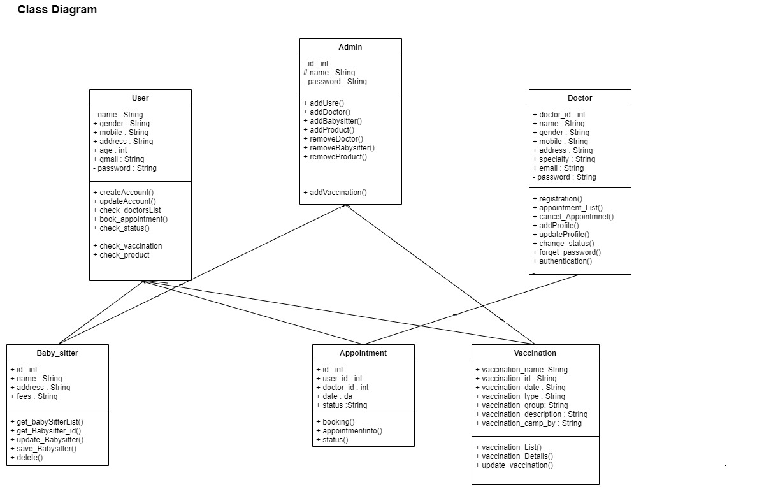

**4.3 Activity Diagram:**

4.3.1 Admin:

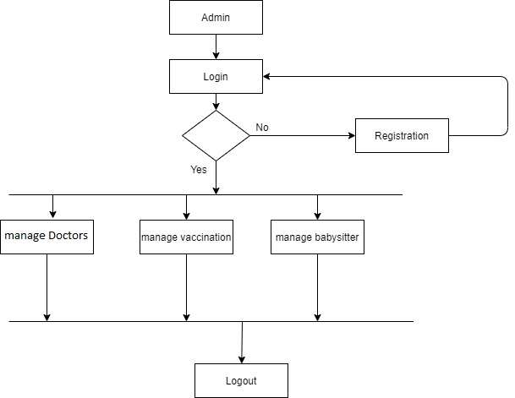

4.3.2 Homepage:

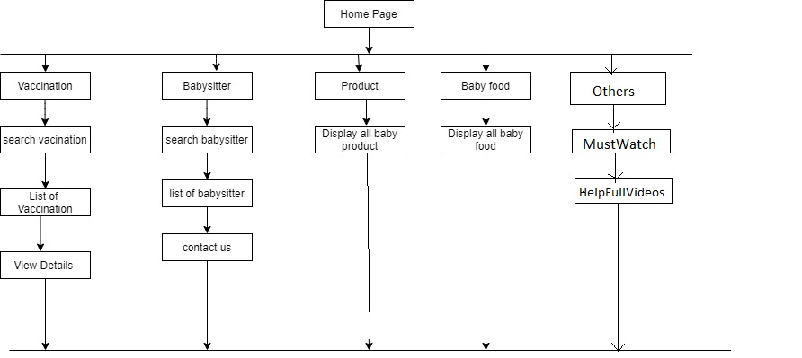

4.3.3 User:

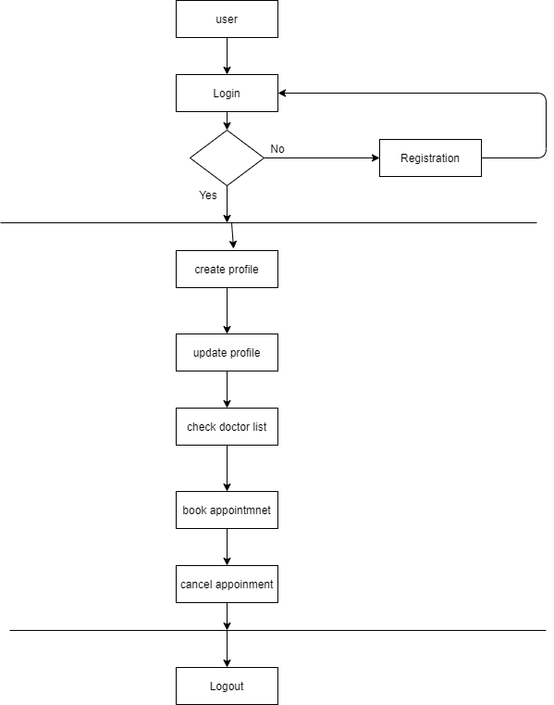

4.3.4 Doctor:

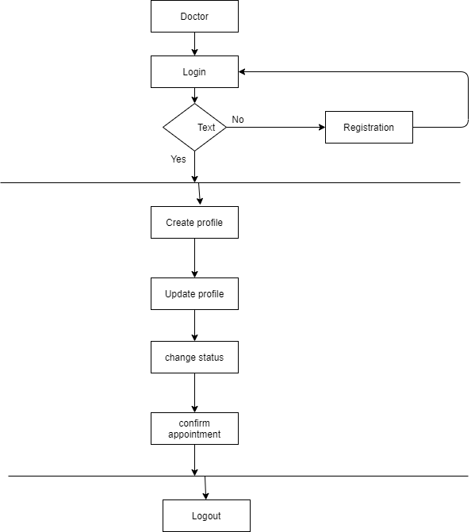

**5. Implementation**

## **5.1 Modules:**

## **5.1.1 Login of Admin**

* + - * The Admin will be able to manage the Childcare Services.
      * The Admin/Manager will be able to add and delete healthcare professionals records.
      * The Admin will be able to add or remove vaccinations camps

## **5.1.2 Login of User**

* + - * The user will be able to get registered and login.
      * The user will be able to View and Book the appointment with the doctor, babysitters and vaccination centers.
      * The user will get notifications via E-mail
      * The user will be able to update his/her details.

## **5.1.3 Login of Doctor.**

* + - * The doctor will be able to manage the all the doctor services.
      * The doctor will be able to cancel appointments.
      * The doctor will get notifications via E-mail.
      * The doctor will be able to update his/her details.

# 

# **5.2 Non-functional Requirements**

## 5.2.1 Performance Requirements

The system should store all the database records of assigned project, assigned task, completed task, task status and requested task and the application should be available for use 24*7 through the server. Also, the application should be user friendly with a proper user interface which makes it easy for the user to understand. All the options should be present in properly accessible places for user convenience.

## 5.2.2 Safety Requirements

All login ids and passwords of the admin, managers and team leader and team members should be protected for privacy using whatever constraints required in the database or the application.

## 5.2 Security Requirements

All passwords of the administrators should be protected for privacy using whatever constraints required in the database or the application. Transactions regarding project manager and admin records should be carried out properly. The database should be protected from attacks and unauthorized access. The interface should be protected from attacks. All passwords should be stored as a secure hash of the administrator password.

**6. Test Cases**

**6.1 Test cases :**

|  |  |  |  |  |  |  |
| --- | --- | --- | --- | --- | --- | --- |
| **Test Id** | **Item to be Tested** | **Steps** | **Input** | **Actual Output** | **Expected Output** | **Pass/Fail** |
| **1** | **User Id** | **User enters user Id** | **User Id** | **Display Success** | **Display Message successful** | **Pass** |
| **2** | **System check for proper username and password entered by users** | **System compares the data entered by user and the entered data in database** |  |  |  |  |
|  |  | **If username and password is valid** |  | **Make Connection** | **Make connection** | **Pass** |
| **If username and password is invalid** |  | **Report invalid user id** | **Report error** | **Pass** |
| **3** | **System checks whether details of user are entered as per the format** | **System checks the data entered by user is in valid form or not.** |  |  |  |  |
|  |  | **If valid** | **User entered data** | **Entered in database** | **Entered in database** | **Pass** |
|  |  | **If invalid** | **User entered data** | **“Invalid Data” message will be printed** | **“Invalid Data” message will be printed** | **Pass** |

**6 .2 Type of Testing used**

**Alpha Testing:-**

Alpha testing allows the team to test the software in a real-world environment. One of the reasons to

do alpha testing is to ensure the success of the software product. Alpha testing validates the quality,

functionality of the software, and effectiveness of the software before it released in the real world. It is

the most common type of testing used in the Software industry. The objective of this testing is to

identify all possible issues or defects before releasing it into the market or to the user.

**7. Screenshots of Webpages**

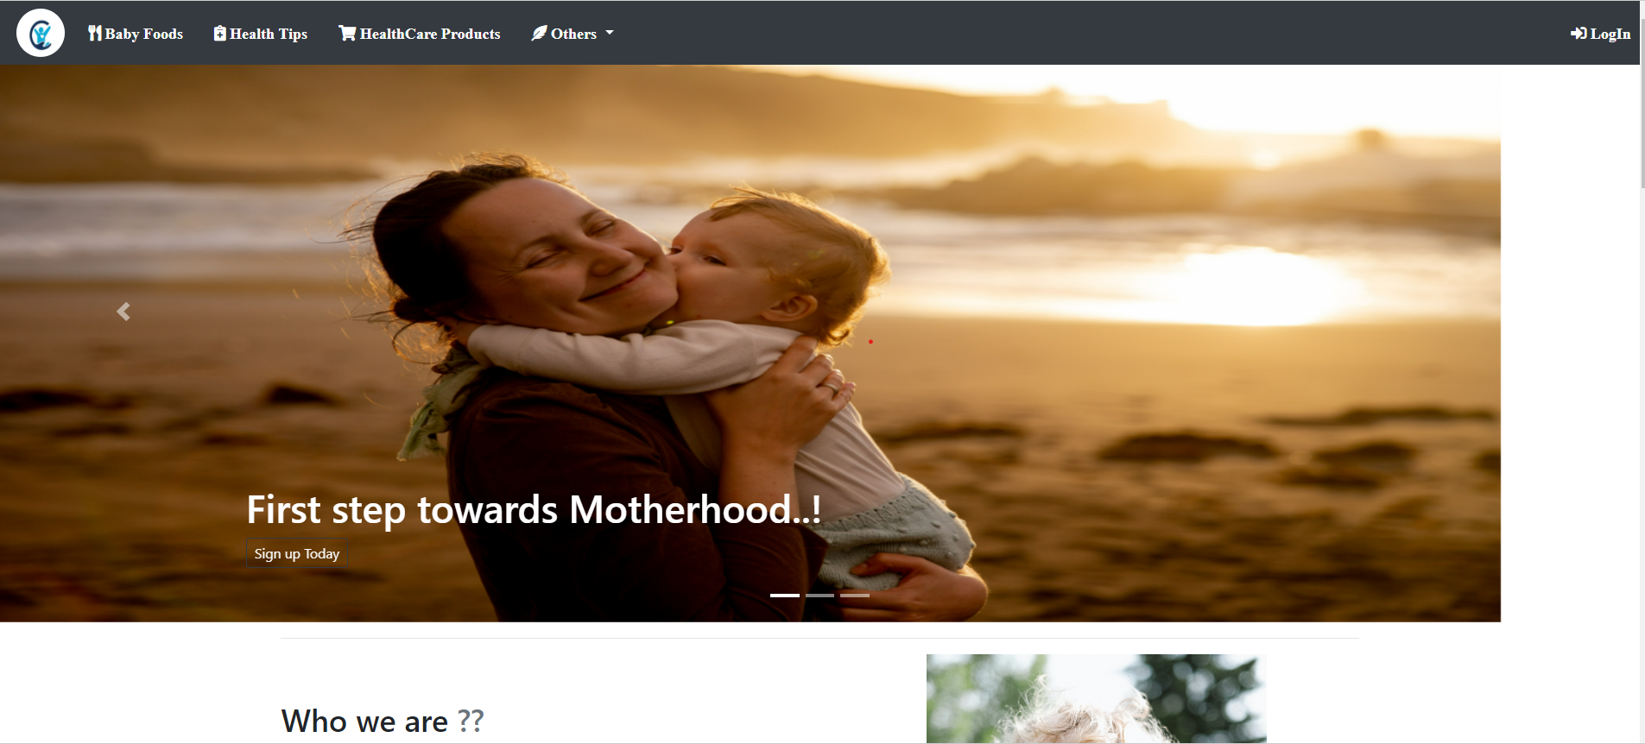

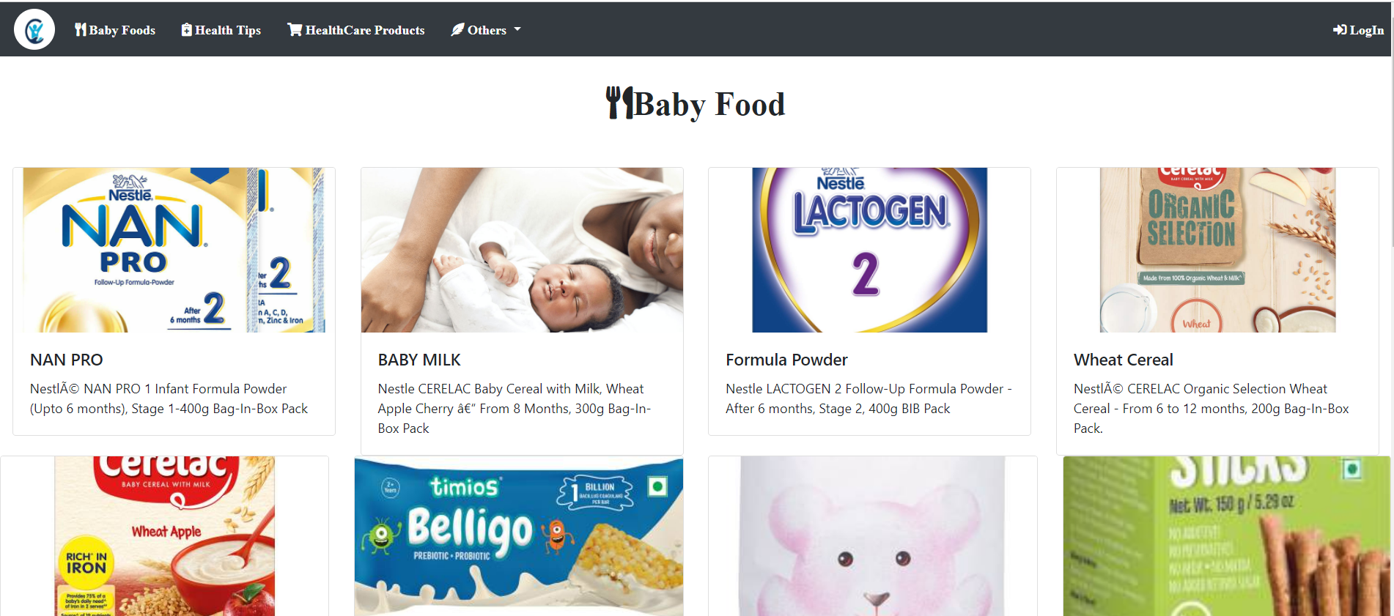

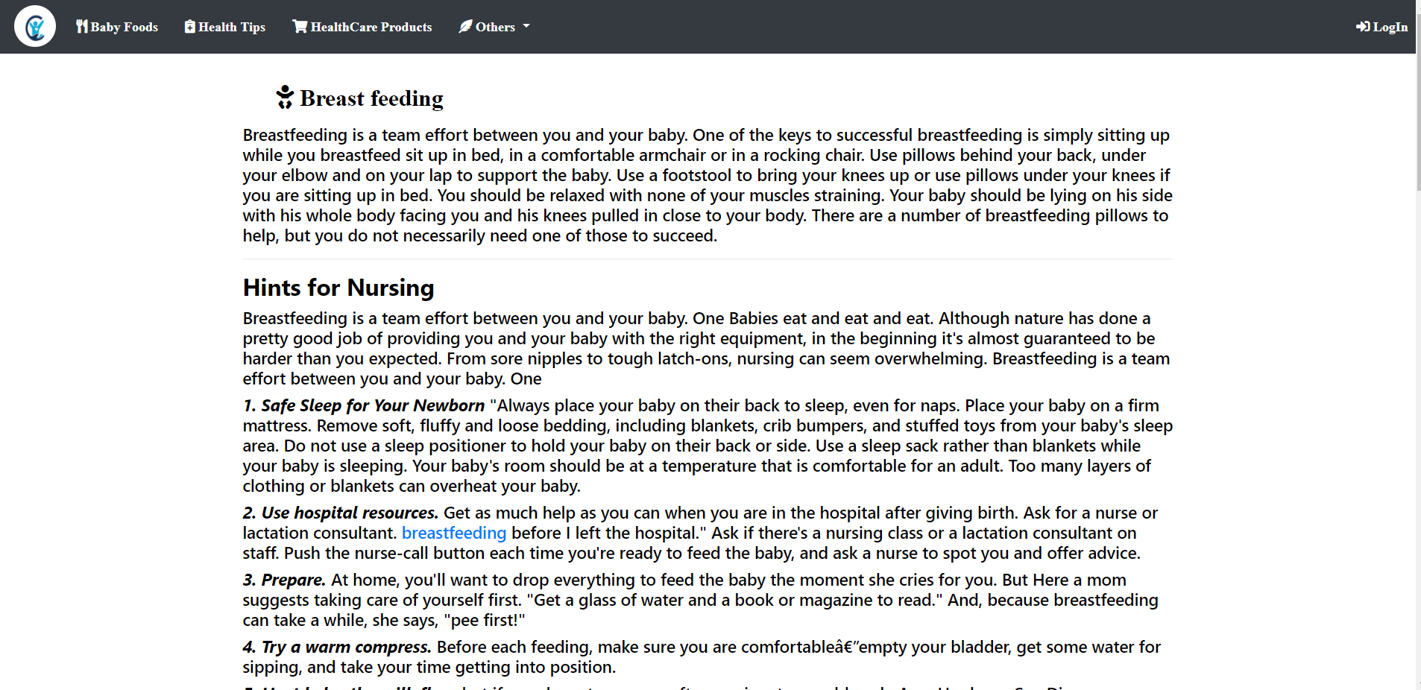

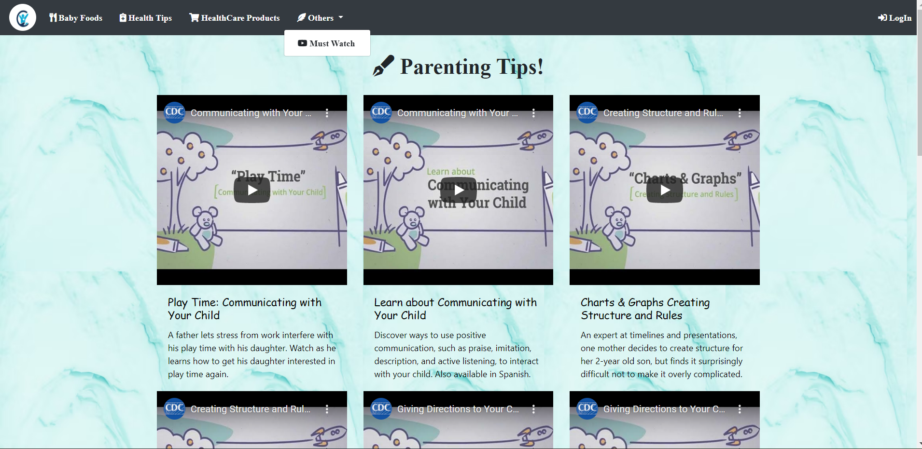

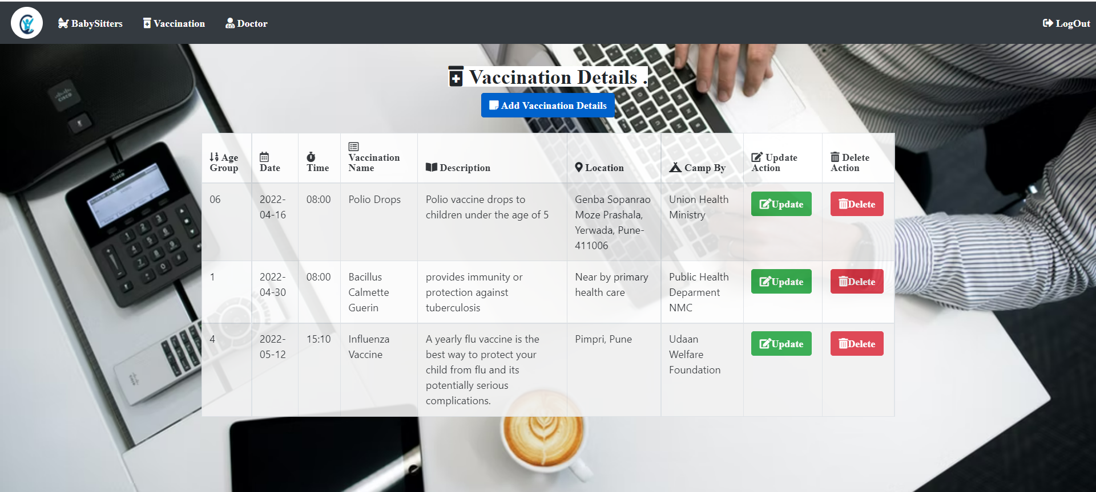

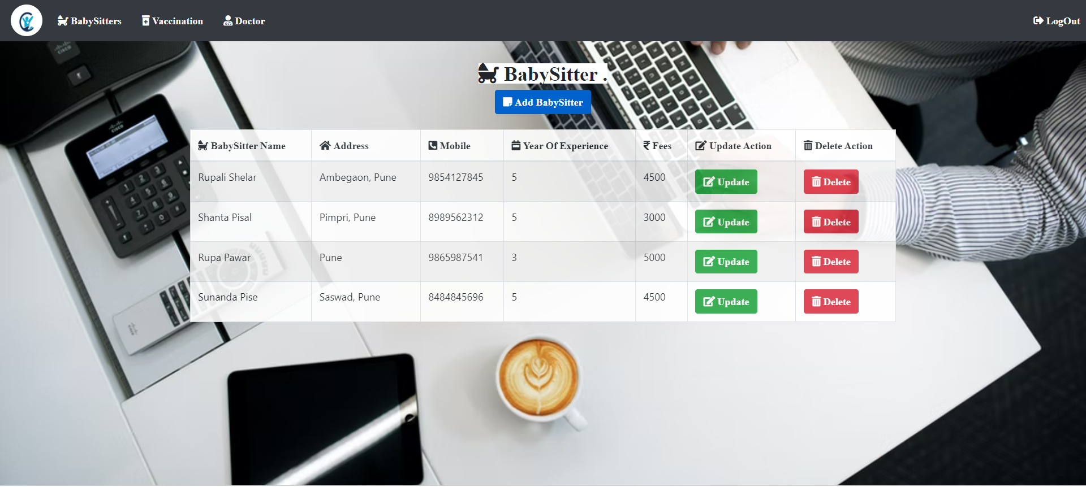

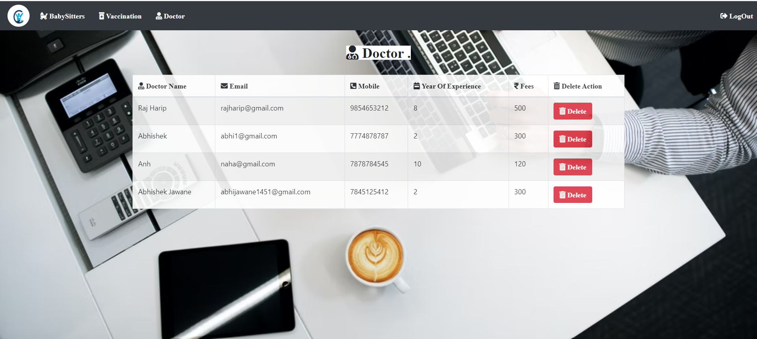

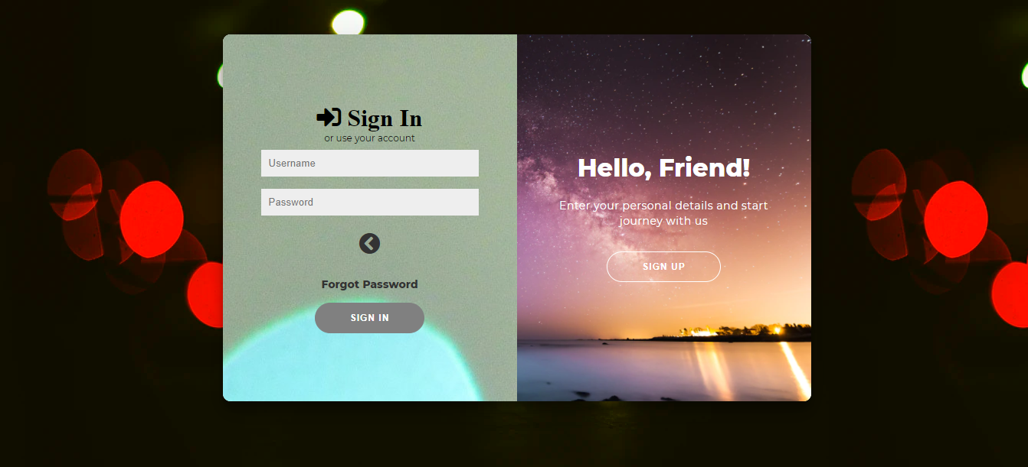

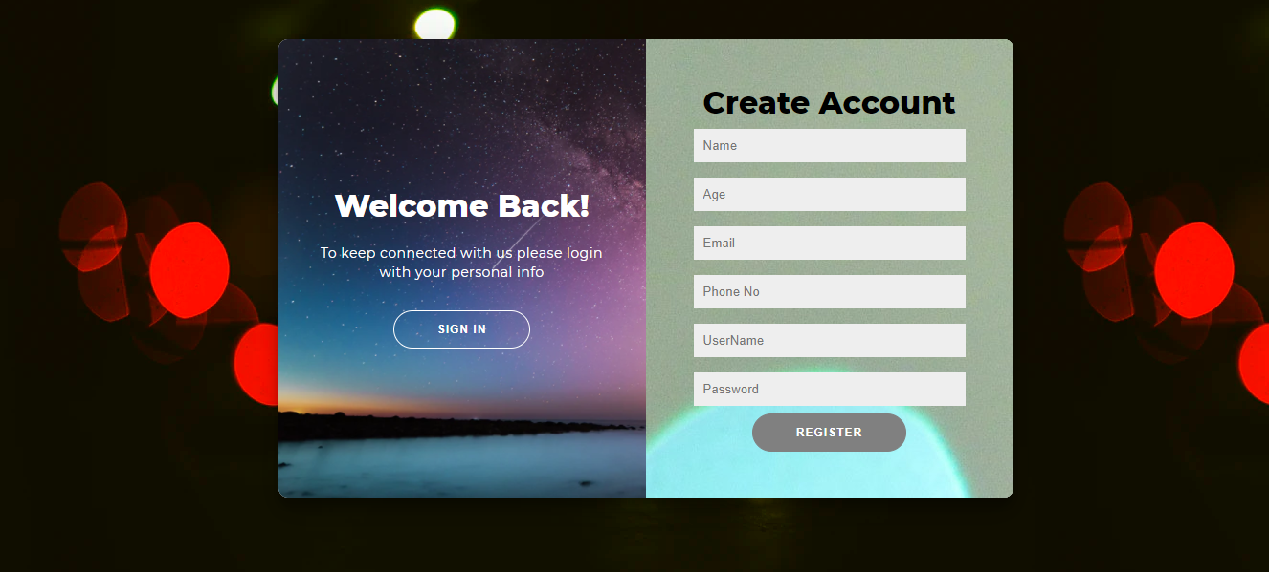

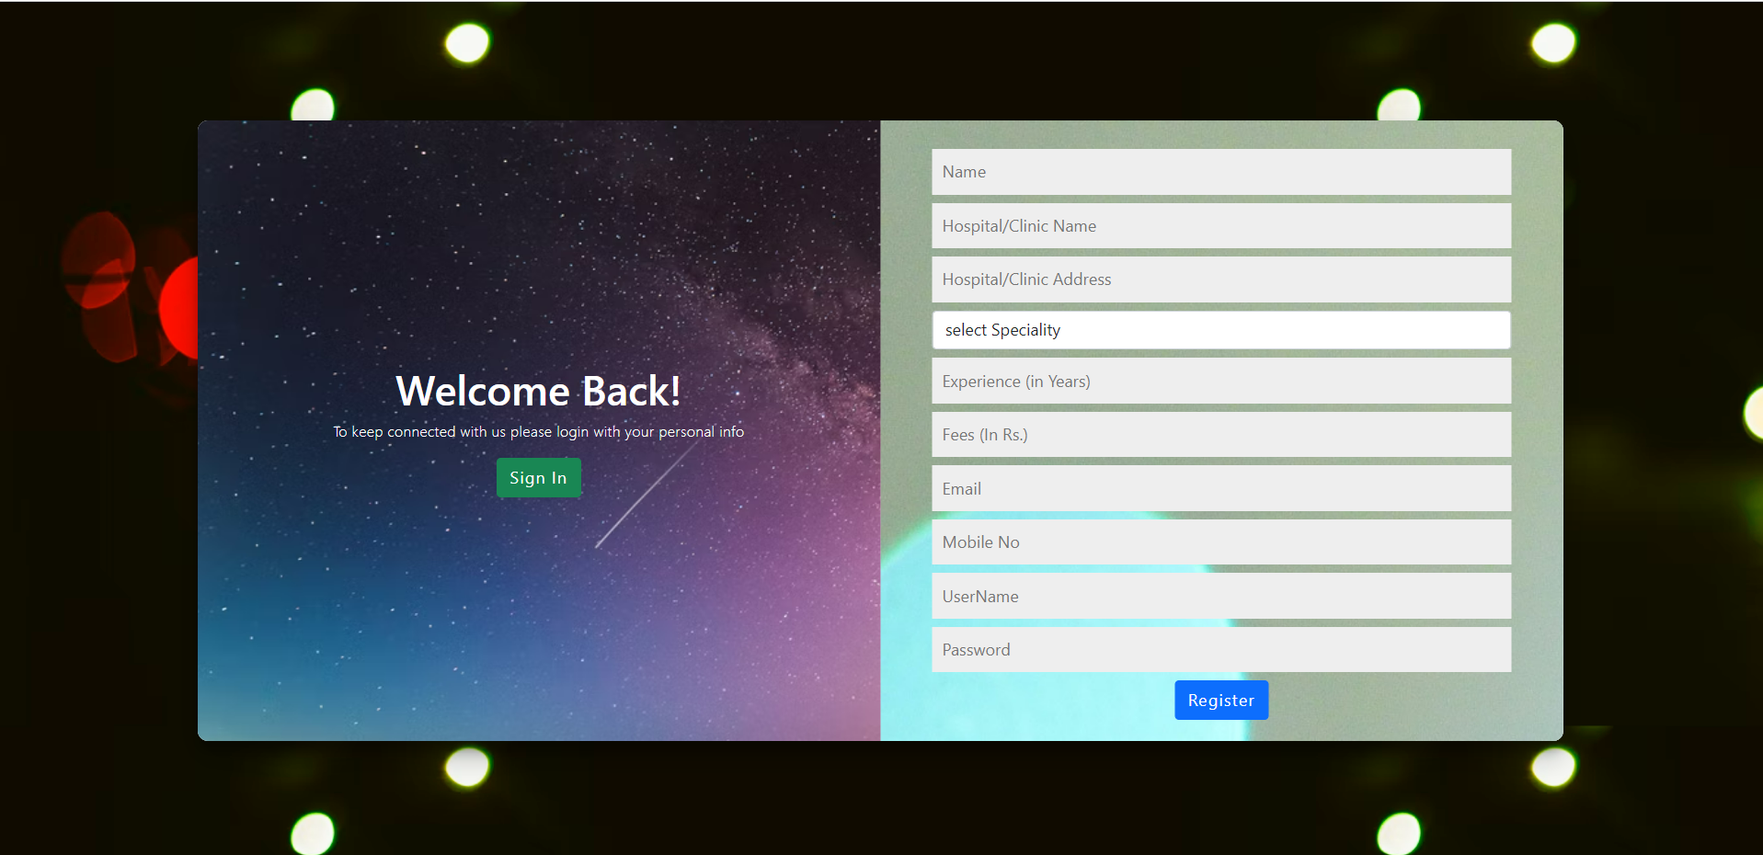

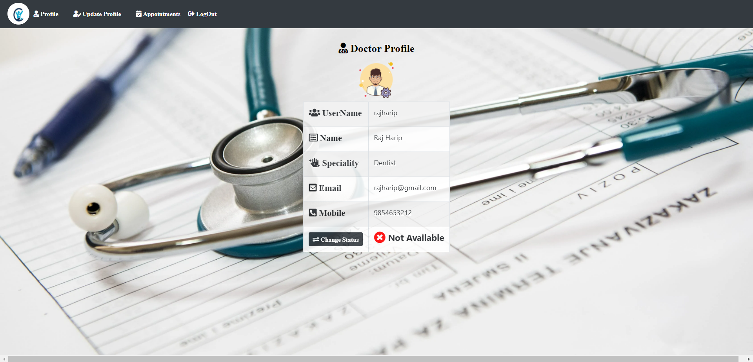

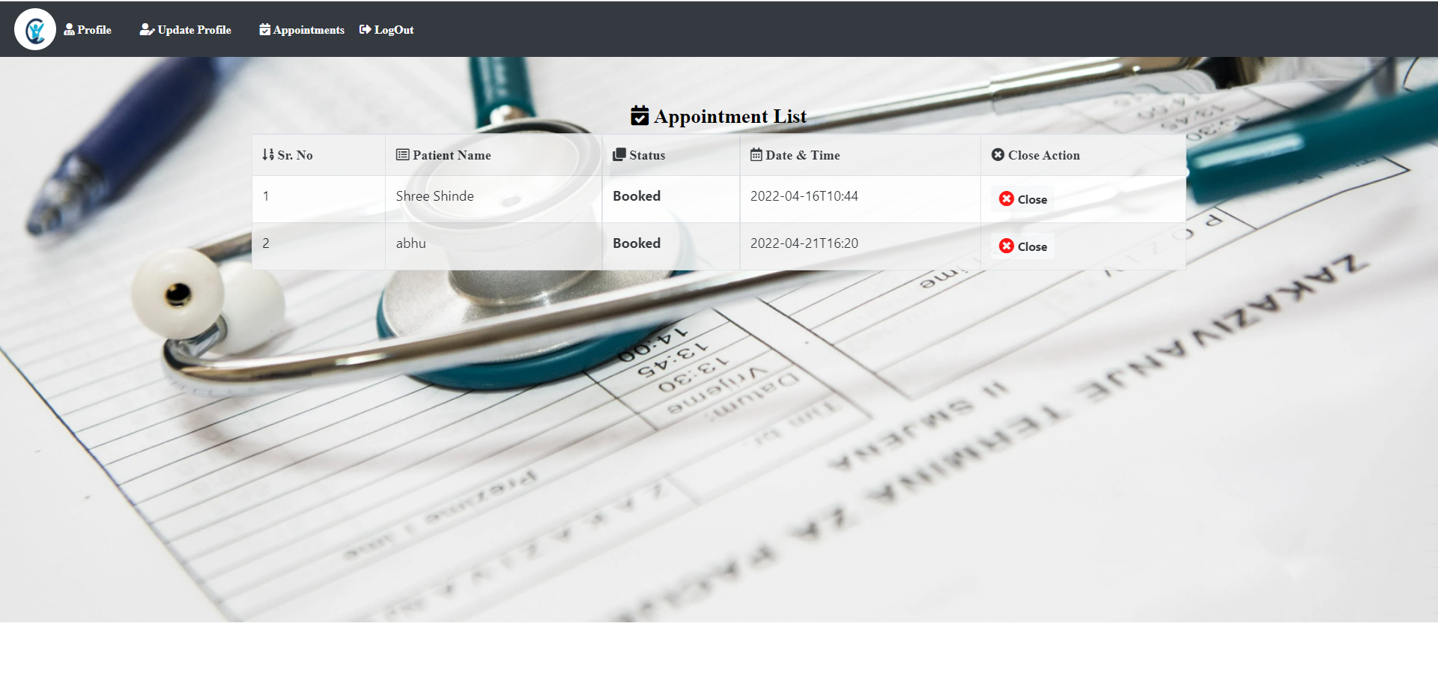

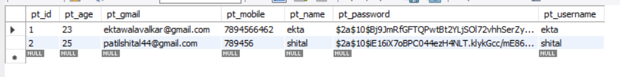

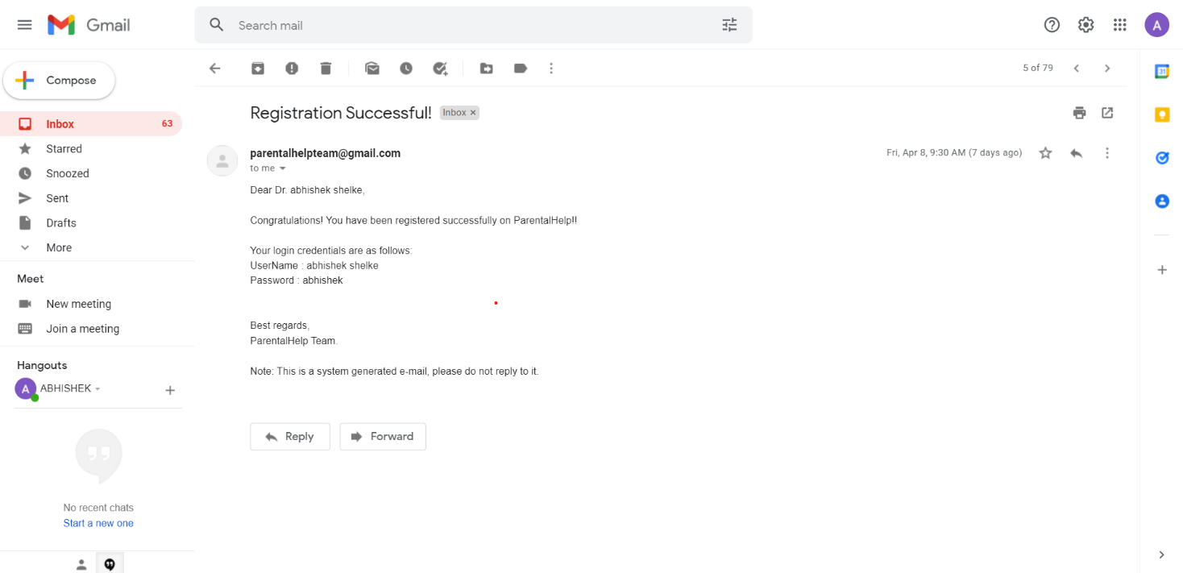

**8. Conclusions**

In today’s fast growing and busy world ,every parent looks for an easy convenient and at the same time professional healthcare and childcare service for their loved ones.Finding everything at one spot is the main thing which everyone looks for in today’s busy life.Providing trusted quality service was the main motto of parentalhelp management system ,so we came up with this idea as our platform provides major facilities such as Healthcare professionals and vaccination services at one stop .We hope this platform will help users find everything they need about childcare ,Working on this project was fun and insightful at the same time as we got to learn a lot of thing about spring.

**9. Future Enhancement**

* In future we trying to implement time bound appointment for doctor and babysitter.
* The scope of this project is to provide Childcare Services at your ease and also on your doorstep, by providing trusted quality products and professionals. One stop for all your baby’s care. Our aim is to connect customers to professionals with ease , also providing required healthcare products at their doorstep.

**10. Acknowledgements**

We take this opportunity to express our heartfelt gratitude towards the CDAC Infoway that gave us an opportunity for presentation of our project in their esteemed organization. With immense pleasure we would like to present this report on the project assignment of. We are thankful to all that have helped us a lot for successful completion of this project and for providing valuable guidance throughout .So we take this opportunity to thank those people who helped us to make this project and the report successfully. We give most sincere guide **Mrs. Harshita Maheshwari** who has always been guiding, encouraging and motivating force. He has provided us with valuable guidance at each and every phase. It has been learning experience, which we will always cherish in our heart. We would also like to express gratitude towards **Mrs. Ulka Joshi** mam for his timely suggestions .It is our proud privilege to express deep sense of gratitude for his comment and kind permission to complete this project. We would also like to thank our parents who provided their wishful support for our project completion successfully. And lastly we thank to our all friends who were directly or indirectly related to our project work.